GRANT EVALUATION CHECKLIST 2023

Please note
We cannot provide a grant to: | Applicable?
- An individual
- A commercial, religious, or political organisation

We cannot provide a grant to a project: | Applicable?
- that is the prime responsibility of another statutory authority
- intended to improve or benefit privately owned land or property
- already complete by the time the grant is made

 | Supplied? | Comments
Name of group/organisation
Charity number (if any)
Website or Facebook (if any)
Applicant’s name
Email
Phone
Position within group
Total cost of project
Amount of grant requested
Other funding obtained

We will only provide grants for charitable, benevolent, social, cultural, recreational, or philanthropic purposes

 | Charitable, benevolent, social, cultural, recreational, or philanthropic purposes
 | Yes? | Comments
Purpose of organisation
Summary of project

We will only provide grants to a group/organisation if the applicant agrees:

Yes?
To use funding solely for the purpose agreed with the parish council
To provide receipted invoices on completion of the project
To give a progress report at our Annual May Parish Meeting

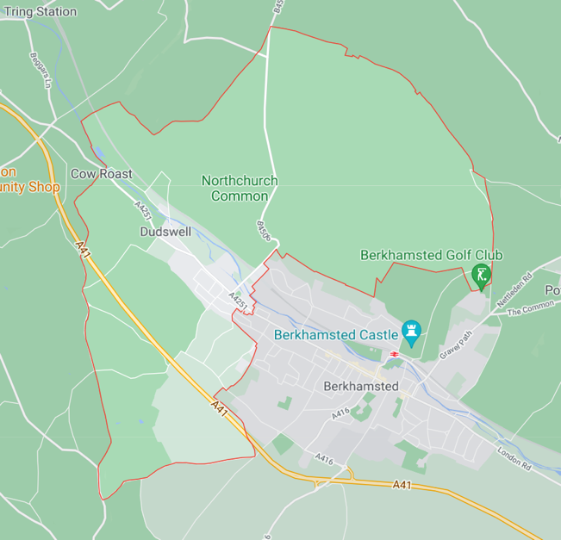
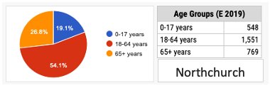
We will only award grants that benefit and involve Northchurch residents.

The pie chart from citypopulation shows the age range.

Highlight how this project will benefit and involve our residents?

(Continue overleaf if necessary)

We will only award a grant to a group/organisation that is well managed:
Please list and submit (or provide a weblink to) any documents which describe your

Supplied?
Aims, objectives
Organisational structure
Meeting and governance procedures
Equalities Policy
Safeguarding policy (if applicable)

We will only award a grant to a project that is financially viable with a bank account operated by at least two joint signatories

Please list and submit the following documents
 | Supplied?
Most recent bank statement
Accounts for the last financial year
Project timeline | (Continue overleaf if necessary)
Breakdown of project costs | (Continue overleaf if necessary)

